Building your Allocated Component
Adding a Basic Presentation Layer

Adding a Basic Presentation Layer 1
Before you Begin 1
Start Your Git Hub Day 1
Adding Code 7
Linking the Middle Layer 13
End Your Git Hub day 19

Adding a Basic Presentation Layer

Before you Begin
Make sure that you have completed the work for last week and that you have watched the eLectures for this week before starting this work.

In order to prove that this is working let’s add a simple web interface to capture some data from the user on one form and pass it to a second form.

Start Your Git Hub Day
As always make a fresh clone of the master and create a new branch to work in.
When the skeleton was set up you will have been allocated four web forms within the AdminSystem web site. In my case these are…
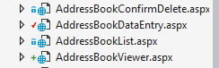
Double click on your allocated DataEntry form and you will see the HTML displayed likes so…
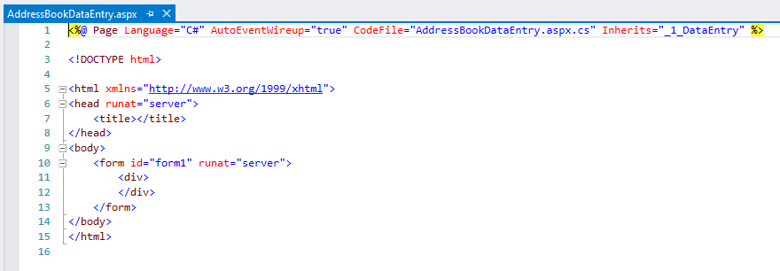
If you enjoy pain, you are most welcome to edit the HTML directly but one advantage of using web forms is that there is an option of a handy drag and drop designer.
At the bottom of the window containing the HTML you should see a button labelled “design”…
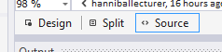
Press this and you will change views to the drag and drop editor…
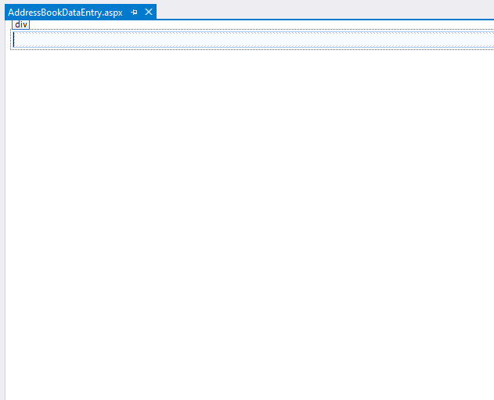
Typically, on the left of the Visual Studio interface you should see the toolbox tab…
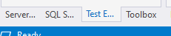
Click this and you should see the list of available controls you may add to the web form…
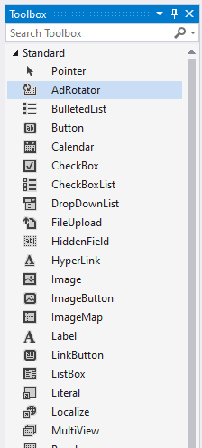
Let’s start by setting up a label control.
From the toolbox drag and drop the following control to the whit background of the web form…
Once done it should look something like this…
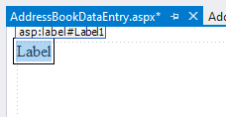
In the bottom right hand corner of the interface you should see a section marked properties…
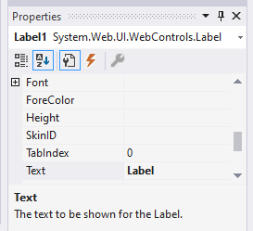
Click the A-Z button to sort them alphabetically, it makes things easier to find.
Locate the property for ID and set it up for the primary key of your table, in my case lblAddressNo. Make sure you get the capitalisation right as it makes it easier to read…
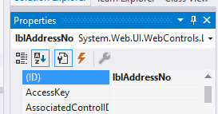
Next locate the property for text and set this with the text the user will see…
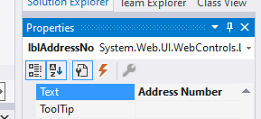

Your web form should look something like this…
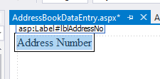
Next set up a text box from the toolbox…
Set the ID to txtAddressNo and leave the text blank.
The web form should now look like this…
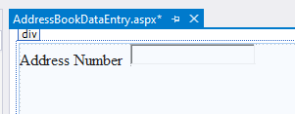
Set up the rest of the properties for the record as controls on the form so that it looks something like this…
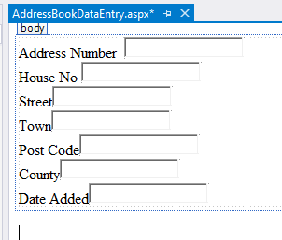
Next create a check box for the Boolean attribute in your table in my case “Active”…
Set the properties like so…
ID chkActive
Text Active
The page should now look like this…
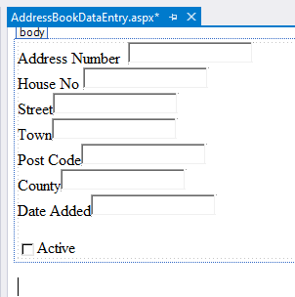
Next add a new label control for error messages called lblError, set the text to blank…
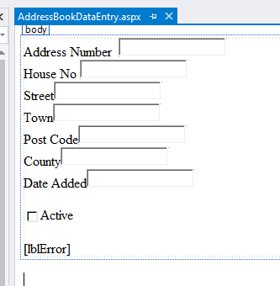
Lastly create two buttons…
Likes so…
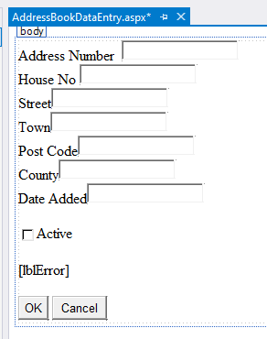
OK has the following properties…
ID btnOK
Text OK
Cancel has these…
ID btnCancel
Text Cancel

Adding Code
Double click on the button for OK and it should take you to the function that handles the click event from the user….
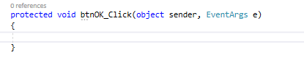
Modify the function so that it navigates to the viewer page for your part of the system…
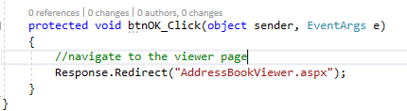
The code should look like this…
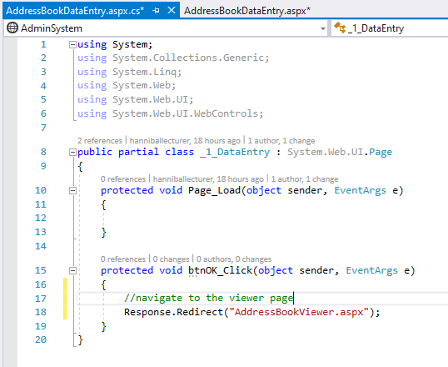
Right click on the AdminSystem web site and make sure it is the startup project for the solution…
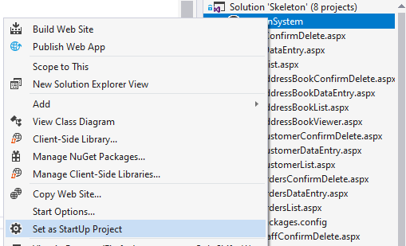

Next right-click on your data entry page to make it the start up page…
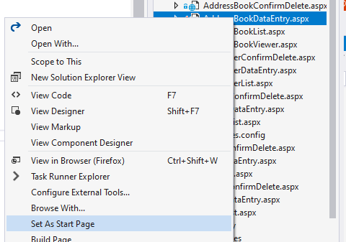
Now press F5 to run the program. If everything works OK you should see the data entry page displayed in the browser…
If you see the following message
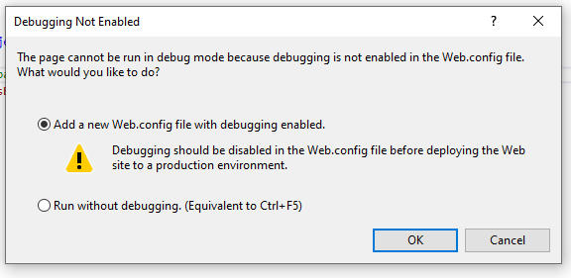
Just press OK
The browser should display the following…
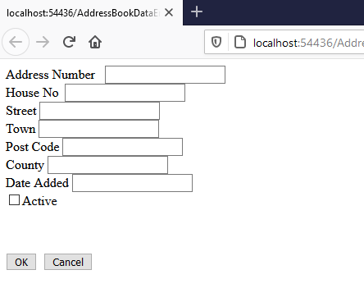
Press the OK button and the browser should navigate to the viewer page …
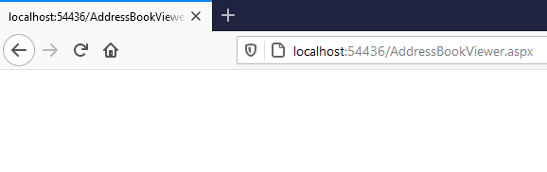
Note there is no content for this page yet.
Stop the browser and get back into editing mode.
You may want to tidy up the interface a bit by extending the size of the label controls.
Click on the longest label once to select it…
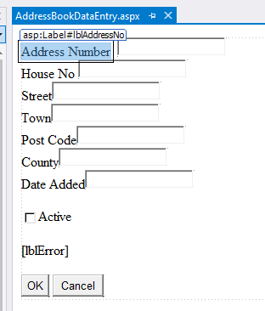
Hold down the control key and while keeping it pressed click once on each label…
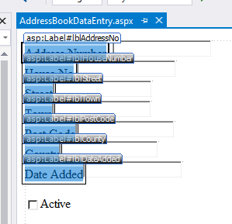
From the main menu select format -make same size - width
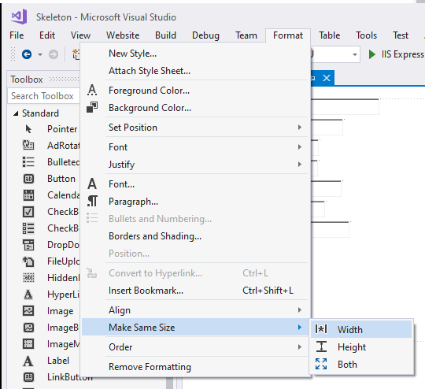
This should make things look a bit more aligned…
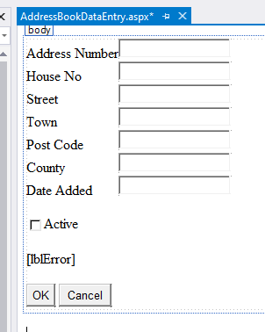

Linking the Middle Layer
We now want to tell this page in the presentation where our code is stored in the class library.
Right click on the web site and select the following…
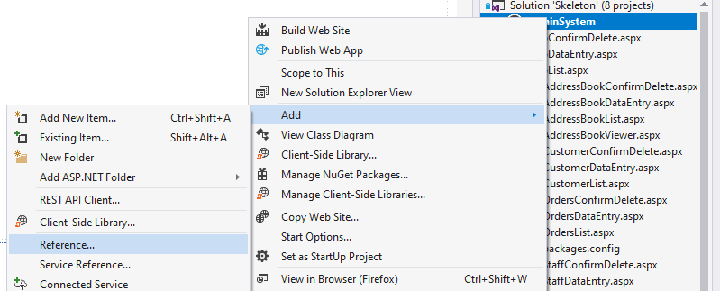
You should see the following page…
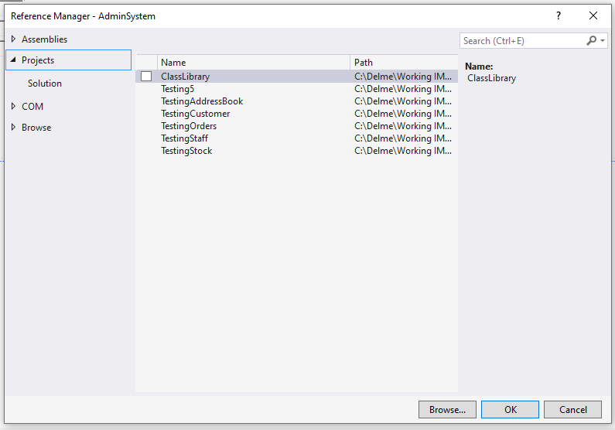
Under Solution you should see your class library listed, make sure there is a tick beside it…
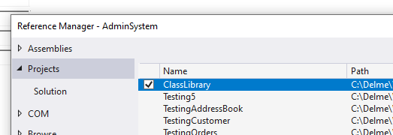

Press OK.
Next sure there is a “using” telling the page to use your class library…
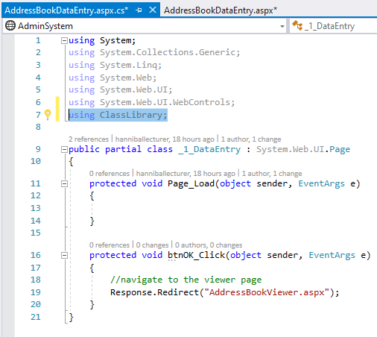
You are now able to use the class you created in the class library within your code.
Modify the OK buttons event handler from this…
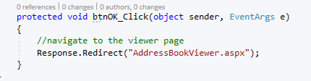
To this…
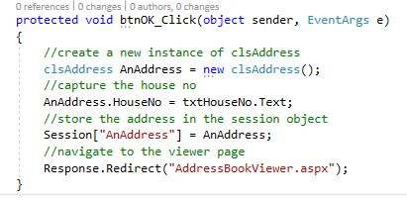
What we are doing here is creating an instance of the class clsAddress and storing some of the data in the object for display on a second page.
We now need to modify the viewer page such that it uses this data to display something.
In AddressVIewer.aspx double click the page to access the event handler for load…
Open the page in design view and double click the page to access the load event of the page...
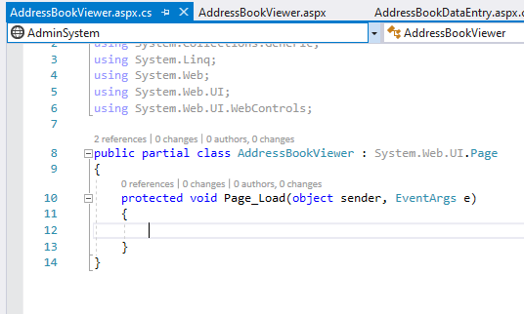
Add a using to the top of the page so that it knows about your class library…
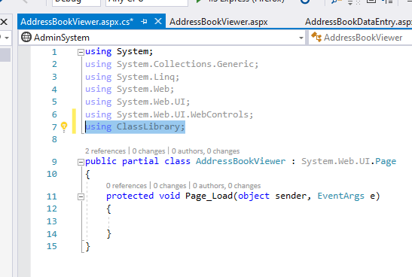
Now modify the load event likes so...
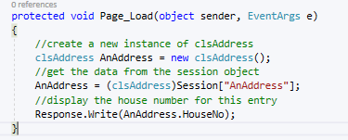
The code should now look like this…
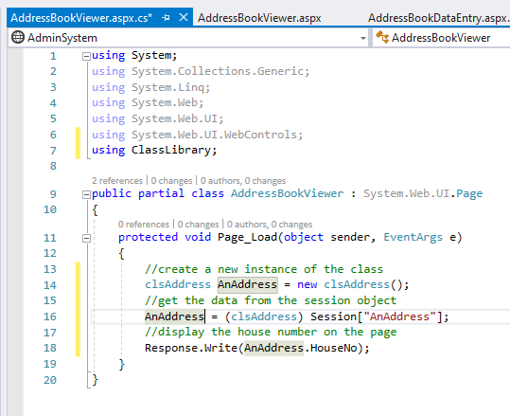

Run the program and you should see the address data entry page displayed...
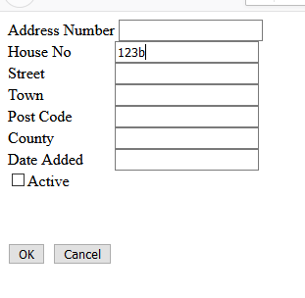
Enter some data as above.
Press OK and the viewer page should be displayed but this time it should display the house number you input on the first page…
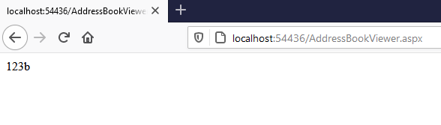
Modify the above code such that you are able to input values for all of the attributes of the class. Do note that as yet the data is not validated so entering bad data will crash the program.

End Your Git Hub day
Once everything is working perfectly merge the work to the master and delete the unwanted branch.

